
Green University of Bangladesh
Department of Computer Science and Engineering (CSE)
Faculty of Sciences and Engineering
Semester: (Summer, Year:2025), B.Sc. in CSE (Day)

Lab Report NO # 01
Course Title: Data Mining Lab
Course Code: CSE-436 Section: 221_D3

Lab Experiment Name: Data Processing and Visualisation Using Python

Student Details

Name |  | ID
1. | Tanvir Ahmed | 221002461

Submission Date : 25/10/2025
Course Teacher’s Name : Mayeesha Farjana

Lab Report Status
Marks: ………………………………… Signature:.....................
Comments:.............................................. Date:..............................

1. TITLE OF THE LAB REPORT EXPERIMENT
Implement Data Processing and Visualization on the Titanic Dataset Using Python.

2. OBJECTIVES/AIM
- Data Preprocessing
- Show the effect of the required visualization techniques.

3. PROCEDURE / ANALYSIS / DESIGN
- Download and import the dataset.
- Analyze and determine what data processing is required.
- Perform the data processing to make it useful for running a model.
- Perform the required visualization techniques.

4. IMPLEMENTATION AND OUTPUT

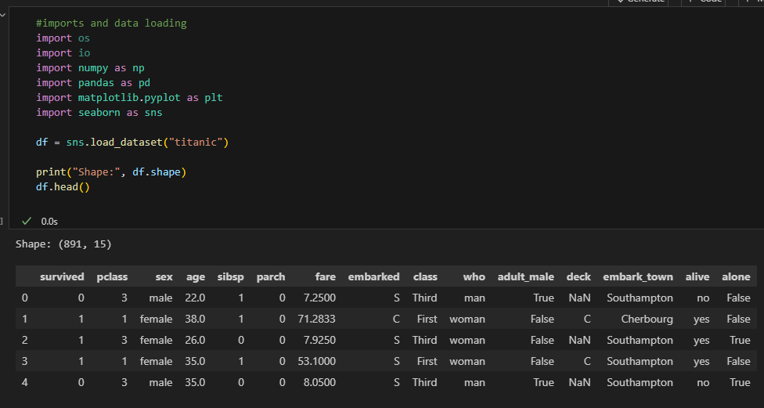
Fig1: Import necessary libraries and the Titanic Dataset

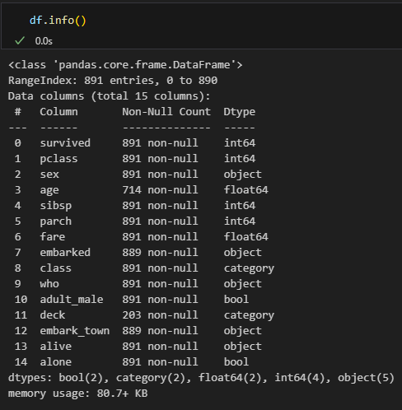
Fig2: Analyse the dataset

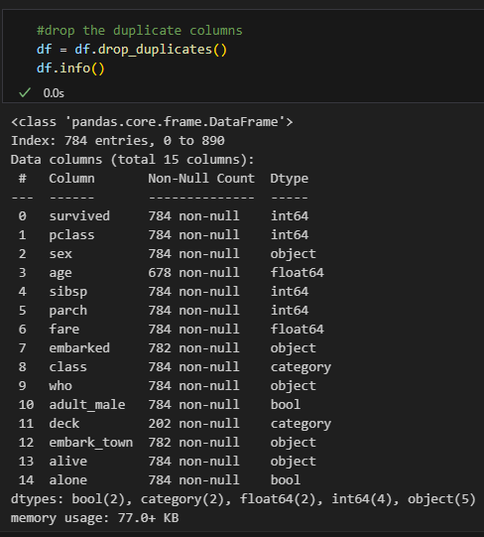
Fig3: Dropping all duplicate rows

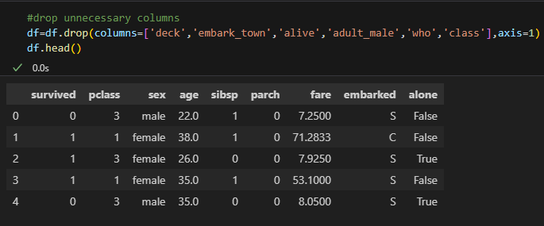
Fig4: Dropping unnecessary columns

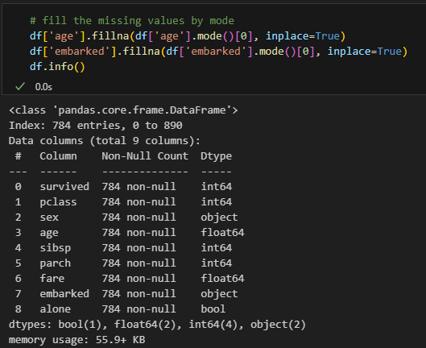
Fig5: Filling Null values with mode value

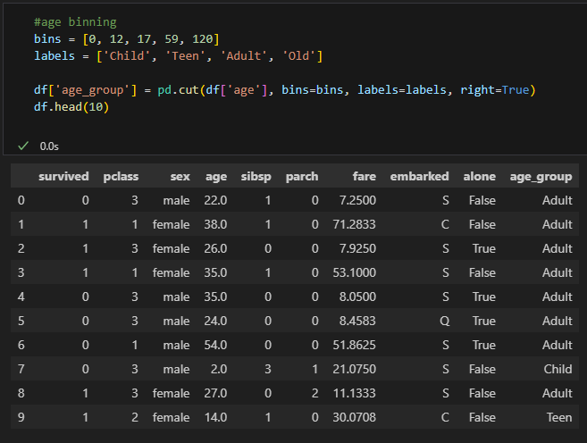
Fig6: Perform binning method on the age column
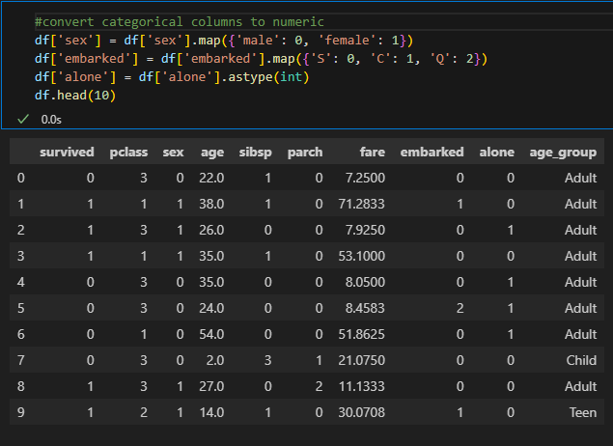
Fig7: Category to numeric so that it can be used in any model.

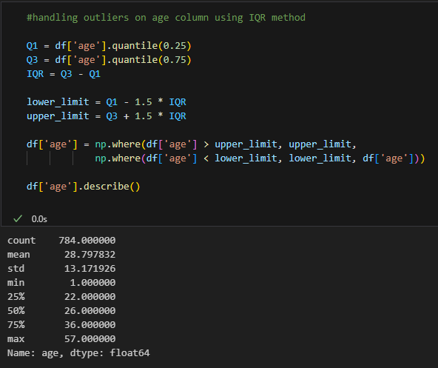
Fig8: Handling Outliers
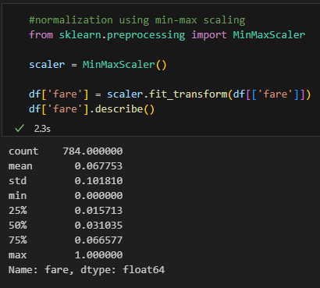
Fig9: Normalize the fare column

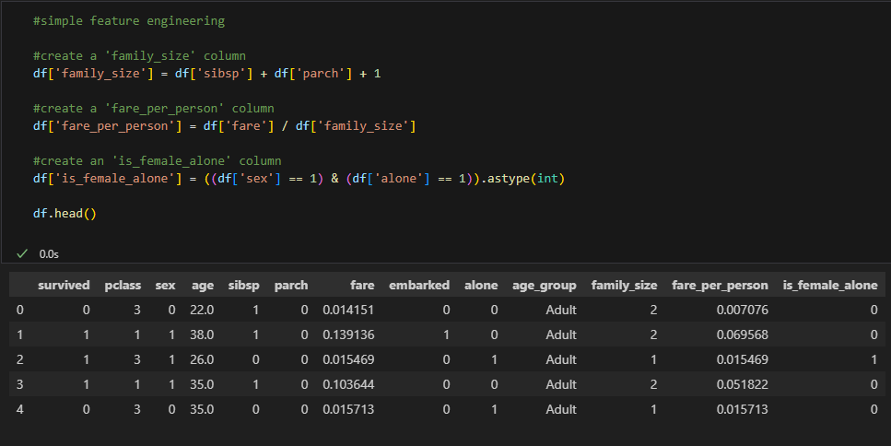
Fig10: Perform a simple feature engineering
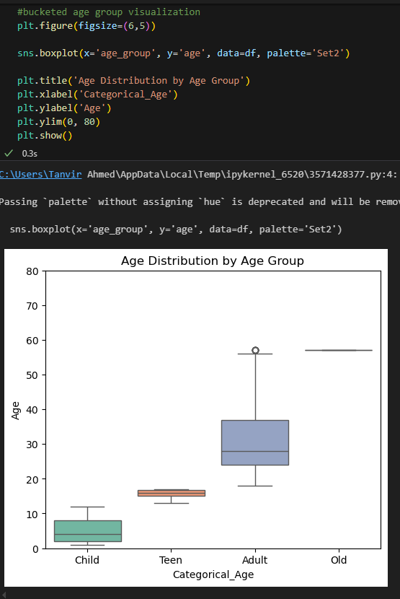
Fig11: Age group visualization

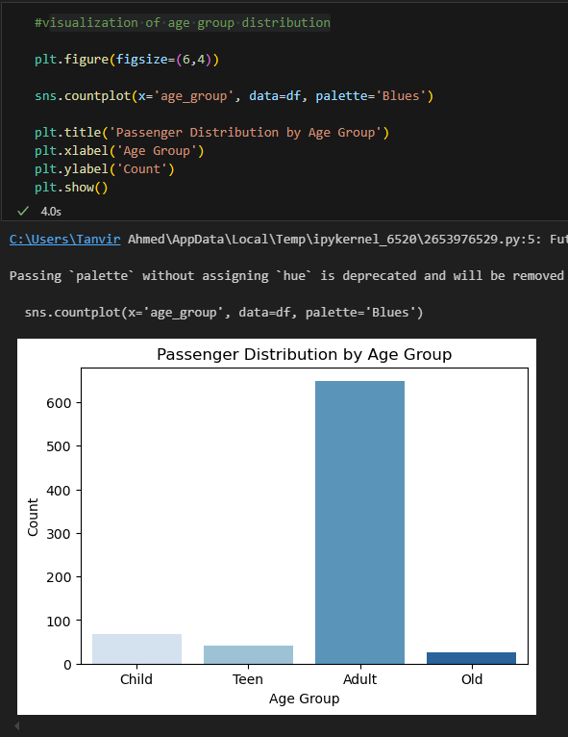
Fig12: Population by age group

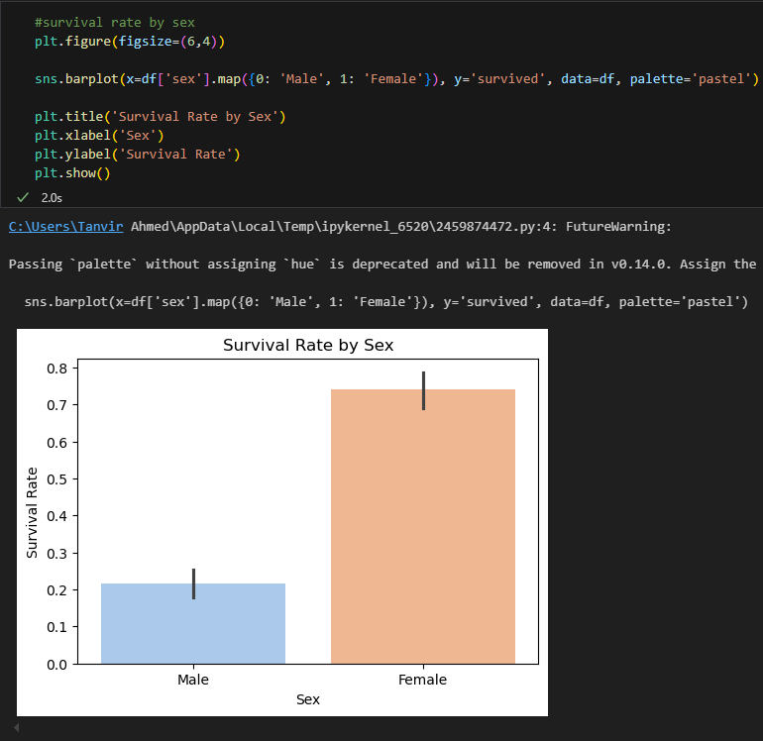
Fig13: Survival rate by age
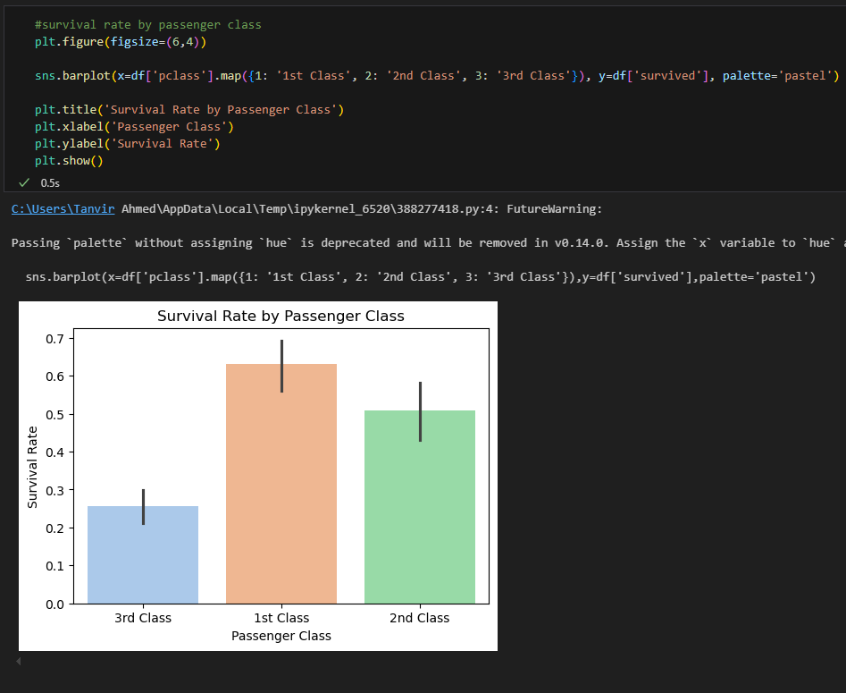
Fig14: Survival rate by pclass
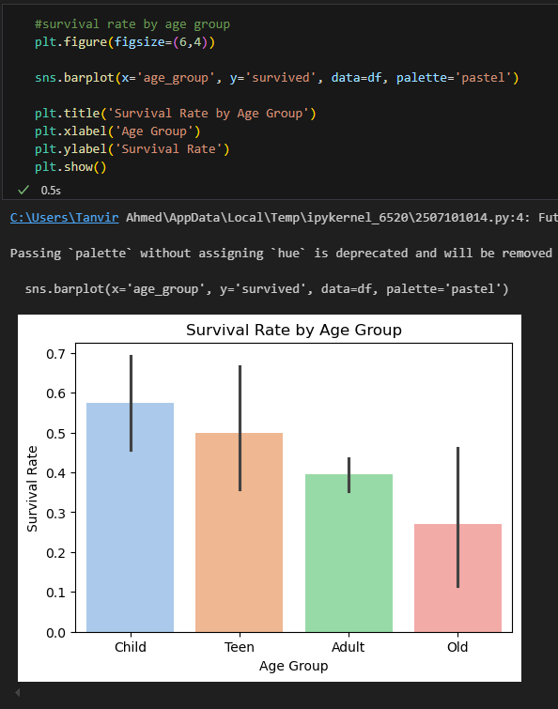
Fig15: Survival rate by age group
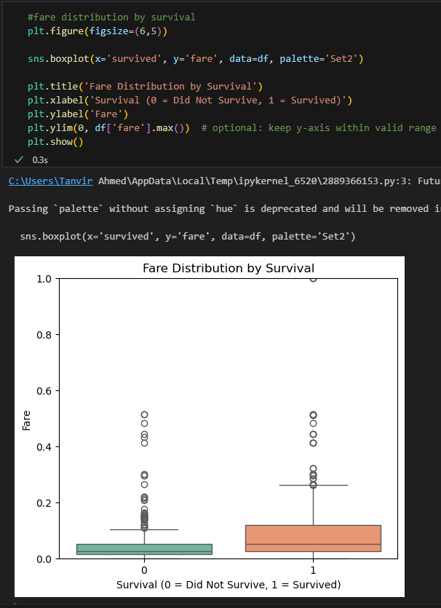
Fig16: Fare distribution by survival
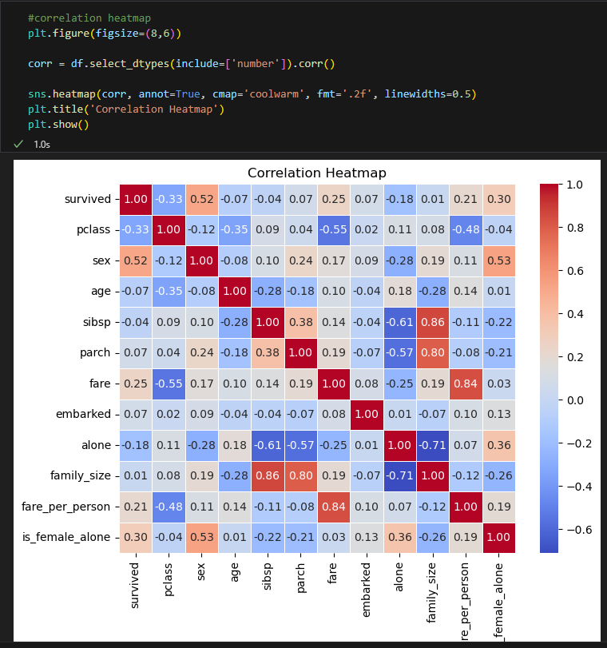
Fig17: Correlation Map

5. ANALYSIS AND DISCUSSION
In this lab, I implemented the data preprocessing and required data visualisation. I implemented almost all of the techniques that I learned from previous lab classes.
These lab classes helped me to understand the overall data preprocessing methods and why data processing is needed. Also, I understand the importance of data visualization in the data mining and machine learning fields. Today, I implement my learnings on a real dataset that helps me to learn more and gain practical experience. Overall, the lab experiment enhanced my understanding of why data processing and visualization are important and where we need these processes.

